======================

TASK 1: TABLE PRACTICE

You should spend about 20 minutes on this task.
The table below gives information about salaries of secondary/high school teachers in five countries in 2009.
Summarize the information by selecting and reporting the main features and make comparisons where relevant.
Write at least 150 words.
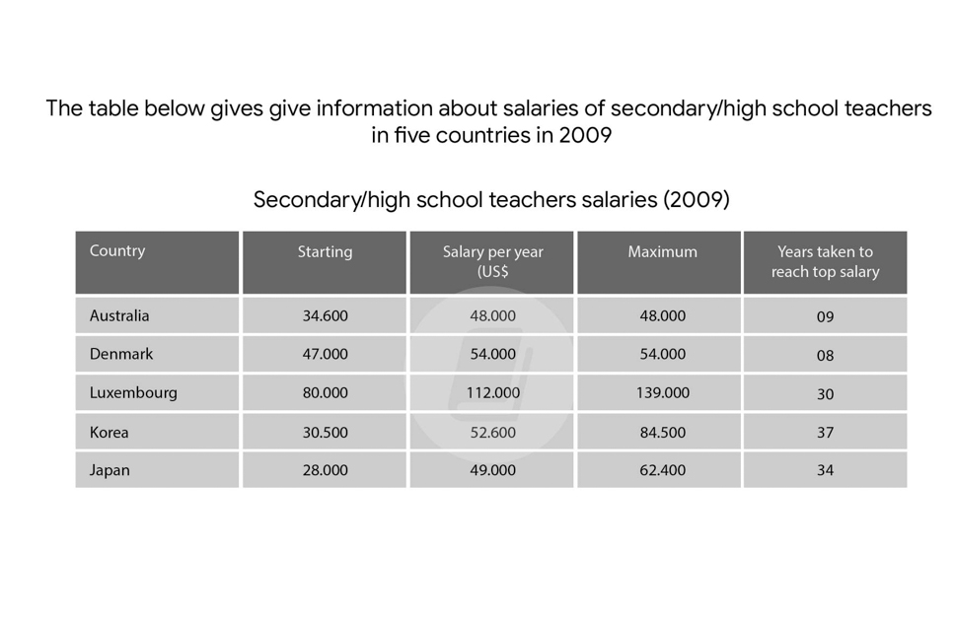

OUTLINE

OVERVIEW:

BODY:

The provided table illustrates data regarding the income of secondary school teachers in five distinct nations in the year 2009.

Overall, the wages including starting, salary per year and maximum of secondary school teachers in Luxembourg exceed / exceeded far beyond those of the other four countries. By contrast, Australia and Japan ranked at the bottom of the list , with salary per year for the former and starting for the latter. As for working time, teachers in five countries have to work a long time for reaching / getting the maximum wage.

As the chart reveals, secondary teachers' starting salary in Luxembourg took the lion's share in five countries ( 80,000 ) , and reaching 139,000 for maximum wage after thirty working years. Australia and Denmark 's starting wage / income amounted to 34,600 and 47,000 respectively sau 12 tháng / in 12 years later. Nevertheless, after nine ?? working years, the salary witnessed a constant number. Tuy nhien, sau khoang more or less than ----lam viec , ca hai muc luong still…… / nevertheless after more than 9 working years, both the salary still witnessed a constant number .

In term of high school teachers' salary in Korea and Japan. The starting pays hit a trough of 30,500 and 28,000 in turn. In the next from 34 to 37 years , the maximum Comprised nearly three times that of the starting.

186 words 50p
BAND SCORE: 5.0

TASK 1: TABLE WITHOUT TIME

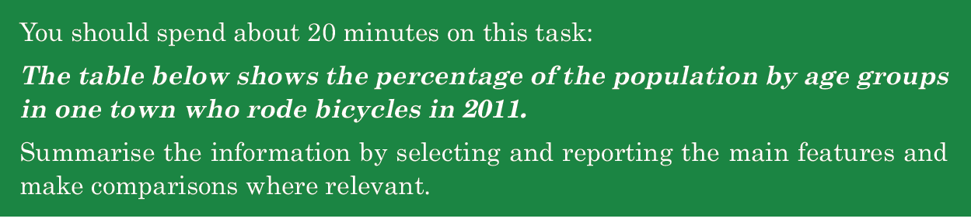

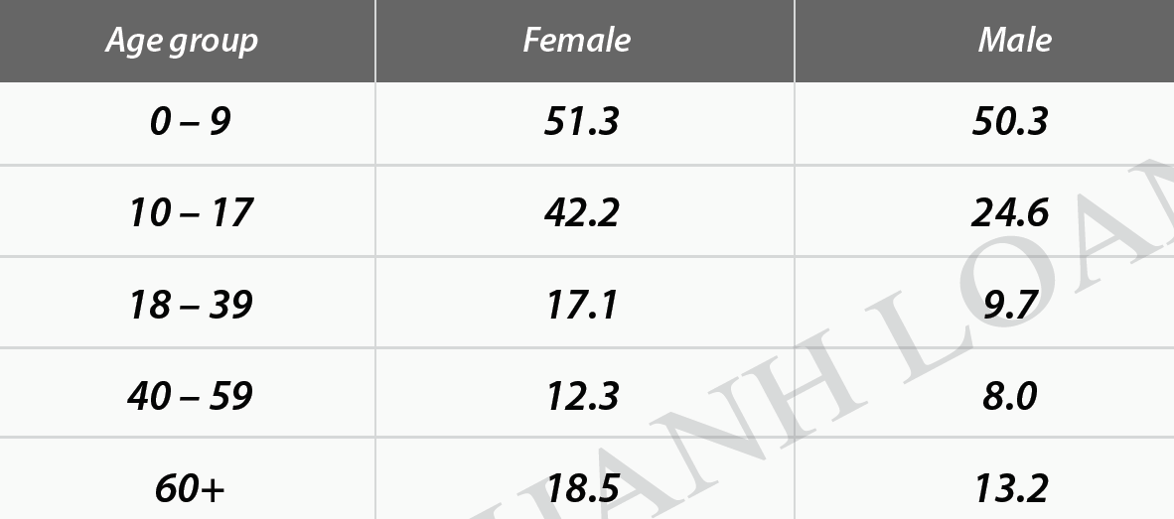
SAMPLE
The table provides data regarding the proportions of people in various age brackets of a town who pedaled in 2011.
Overall, the youngest age group (0-9) took the lion’s share in the number of people enjoying riding a bike, whereas the reversal was true for the age group 40-59. Additionally, the percentage of females who cycled every day exceeded that of males over the same period.
As the chart reveals, among five groups, under 9-year-old cyclists accounted for the largest proportion that year, with the figure for females outnumbering that of males, at 51.3% and 50.3% respectively. The disparity between the two genders was broadened when it comes to the 10-17 age group, with 42.2% of females and 24.6% of males. However, as for the older age (18-39), both genders’ figures commuting by bike declined significantly, amounting to approximately a third of the 10-17 group’s figures.
In term of the two oldest groups, 12.3% of females in their 40s and 50s used bike, 4.3% higher than the figure for their male counterparts. In contrast, the popularity of pedaling increased when people reached 60+, but this mode of transport was still more widely-used among females than males, occupying 18.5% and 13.2% consecutively.
199

Outnumber/ surpass/ overshadow /overtake

Respectively
In turn
Consecutively
orderly

Disparity=difference

Về mặt , đề cập đến
As for
In term of
Concerning
Relating to
Regarding
When it comes to

In contrast,
However,
Meanwhile.
-----while, whereas, whilst-------
Conversely,
On the other hand,
Regarding the other three age groups from 18 to over 60, the female figures always outnumbered those of male, altering from 12.3 to 18.5 for female, and between 8.0 and 13.2 for male.

Vary / alter/ oscillate from----to dao động trong khoảng
between ----and

